RepoHIVE: Deterministic, Adaptive Hierarchy Construction for Navigating Large Code Repositories
Author Name(s)
Author Affiliation(s)
E-mail
Abstract: Large software repositories confront both human developers and AI coding agents with the same obstacle: a flat dependency graph of thousands of nodes and tens of thousands of edges that cannot be rendered legibly, cannot be placed in a language model context window, and offers no entry point for exploration. Existing systems either retrieve from the flat graph, apply one global clustering strategy to the whole codebase, or derive hierarchies from language model summaries that differ between runs. We present RepoHIVE, which transforms the dependency graph of a Java repository into a navigable multi-level hierarchy of repository, groups, files, and functions. The contribution is adaptive, per-region hierarchy construction driven by structural quality: rather than imposing a single global method, RepoHIVE measures the cohesion and coupling of each region and decides, region by region, whether to preserve the existing package boundary or to reconstruct it through dependency-based community detection. The construction is deterministic by design. Canonical ordering, content-addressed identifiers, and seeded detection make the output byte-identical across runs and invariant under permutation of the input. Every region score, every decision, and the full resolved configuration are recorded, so a result reproduces from its own audit record and the decision boundary is an empirically calibrated, auditable parameter rather than a hidden constant. A stable JSON contract lets one engine serve a semantic-zoom viewer, a bounded-context retrieval model for agents, and a static impact query. We describe the algorithm, the determinism and reproducibility strategy, and an evaluation framed strictly around code navigation. Performance figures are engineering estimates unless explicitly marked as measured.
Index Terms: software comprehension, dependency graph, hierarchical clustering, community detection, code navigation, static analysis, determinism, reproducibility, program understanding, retrieval for code, software architecture recovery.

I. Introduction
Software systems grow, and as they grow they become harder to understand. A mature enterprise codebase routinely contains thousands of source files, tens of thousands of classes and functions, and a dense web of dependencies between them: one class imported in dozens of places, one utility called across the whole system. Two very different consumers now need to make sense of that scale. The first is the human developer, who may be onboarding onto an unfamiliar project and must build a mental model before making any change. Empirical studies report that program comprehension consumes more than half of a developer's working time [3]. The second is the AI coding agent, which is increasingly used to complete, repair, and refactor code, but whose effective working memory, the language model context window, holds far less than a single large module.
The natural artifact for reasoning about a codebase at this scale is the dependency graph: a directed graph whose nodes are code entities and whose edges are the references between them. At real scale, however, the dependency graph is not a solution but a restatement of the problem. A graph of thousands of nodes and tens of thousands of edges is an unreadable tangle. It cannot be drawn on a screen in a way a human can follow, it cannot be handed wholesale to a language model, and it offers no obvious place to begin. Fig. 1 contrasts the flat graph with the navigable hierarchy RepoHIVE produces from it.
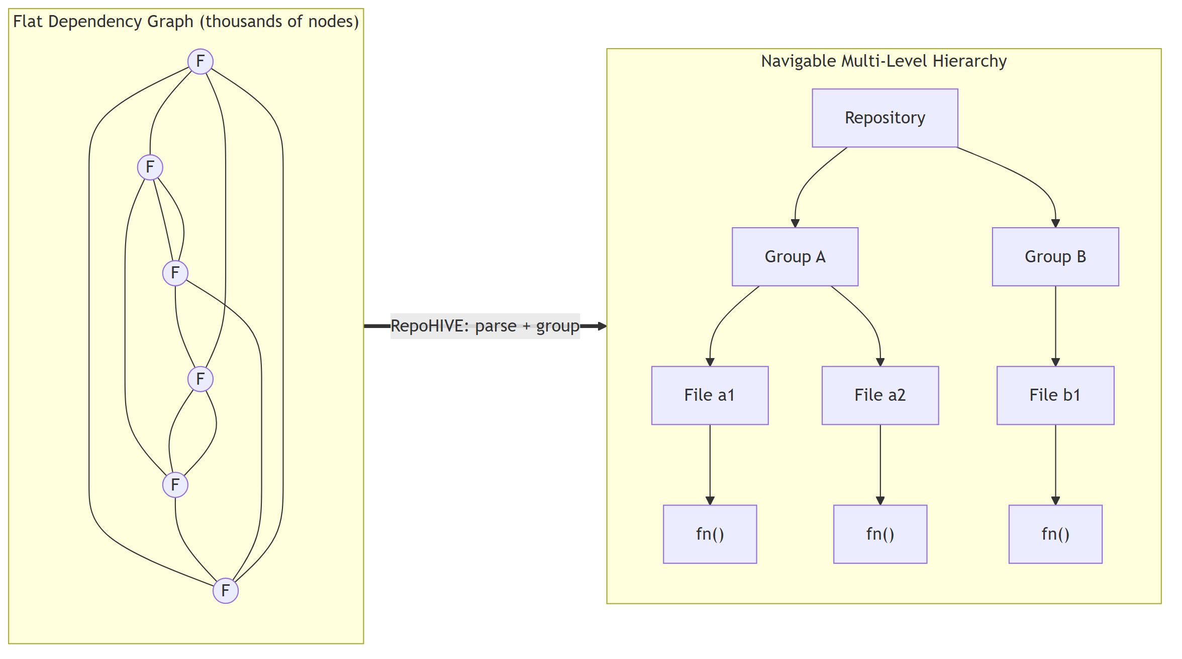
Fig. 1. The core problem and the RepoHIVE transformation. A flat dependency graph, unreadable at scale, becomes a navigable multi-level hierarchy.
The reflexive answer, to use the folder structure, fails on inspection. Directory trees record how files were saved, not how the code depends on itself. A well-named folder may hold classes that barely interact, while two tightly coupled classes may sit in different directories. Folder structure is therefore a weak and sometimes misleading proxy for the structure that matters for comprehension.
RepoHIVE constructs, from the dependency graph, a multi-level hierarchy of the form repository, level 1 groups, level 2 groups, files, and functions, so that a reader or an agent can start at the top, see a small number of large regions, descend into the one that matters, and never confront the whole graph at once. The defining idea is that the hierarchy is built adaptively. RepoHIVE measures the structural quality of each region and decides, per region, whether to keep its existing boundary or to rebuild it from the dependency structure, instead of applying one strategy everywhere. Every decision is recorded, and the whole pipeline is deterministic.
The contributions of this paper are the following. First, adaptive per-region construction, a hierarchy-construction policy that assesses each region's cohesion and coupling and chooses between a preserve action, which keeps the existing package boundary, and a reconstruct action, which rebuilds the region through community detection. To our knowledge this per-region preserve-versus-reconstruct decision, driven by measured structural quality, is not present in the software clustering literature. Second, determinism as a designed property. The same repository and configuration always produce byte-identical output: identifiers are content-derived, every iteration that can affect output runs over a canonically ordered collection, community detection is seeded, and the result is invariant under permutation of the input node and edge order. Third, reproducibility and auditability. Every region's scores, decision, decision confidence, and the complete resolved configuration are written to the index, so any result reproduces from its own record and the decision boundary is an empirically calibrated parameter open to sensitivity analysis rather than a constant buried in code. Fourth, a stable contract with three consumers, one index format serving a semantic-zoom viewer for humans, a bounded-context traversal model for agents, which responds directly to the degradation of language models on long contexts [8], and a static impact query. Fifth, an evaluation design framed strictly around code navigation, with baselines reachable purely through configuration so that any difference is attributable to the construction policy alone.
II. Related Work
Flat code graphs and retrieval. A line of recent systems builds a dependency or call graph of a repository and retrieves from it to support an AI task. RepoGraph [7] constructs a line-level code graph with Tree-sitter and supplies ego-graph context to coding agents, improving bug-fix resolve rates on real issues. Knowledge-graph approaches to repository-level code generation [2] store code entities and relations in a graph database and retrieve relevant subgraphs before generation. RepoCoder [9] iterates retrieval and generation using similarity search over sliding-window code snippets. These systems demonstrate convincingly that structural, cross-file context improves AI performance on code tasks, and they share our reliance on AST-based graph extraction. They differ from RepoHIVE in operating over a flat graph: they retrieve well when the target is known, but they offer no multi-level organization for exploration and no notion of grouping quality.
Hierarchical summarization. Two recent systems build hierarchies over code. Code-Craft [6] performs bottom-up call-graph summarization, propagating summaries upward, and reports large retrieval gains on large codebases. A hierarchical summarization approach for business applications [3] segments files through the AST and aggregates function summaries into file-level and package-level summaries. Both confirm that hierarchy helps at scale, but both derive the hierarchy from either call-graph depth or on-disk file structure, and both rely on language-model-generated summaries, which makes their hierarchies non-deterministic. RepoHIVE instead derives grouping from the measured structural quality of the cross-file dependency graph, and is deterministic by construction.
Software module clustering. A large body of work clusters software modules to recover architecture or aid comprehension. The systematic review by Sarhan et al. [10] catalogs 143 such papers and identifies dependency-graph-based clustering with community-detection or agglomerative algorithms as the state of the art, with Modularization Quality and MoJoFM as standard evaluation metrics. It explicitly names adaptive clustering that adjusts to system characteristics as an open direction. Stana and Sora [5] combine structural and co-change dependencies and evaluate Louvain, Leiden, and DBSCAN, confirming both the value of richer edge signal and the effectiveness of Louvain-family detectors on Java systems. Every clustering approach in this literature applies a single global strategy to the whole codebase. None measures quality per region and switches strategy accordingly, which is precisely the gap this work addresses.
Software architecture quality. Druskat et al. [4] argue that architectural quality, measured through cohesion, coupling, cyclomatic complexity, and change coupling, governs the maintainability of software, and that high-level architectural problems are poorly captured by ordinary code-smell detectors. This grounds the cohesion and coupling measures RepoHIVE uses to drive its decision.
Context injection for language models. Ehsani et al. [1] show that structured, layered injection of repository and project context substantially improves language-model program repair, while injecting all context at once degrades it. Liu et al. [8] demonstrate the lost-in-the-middle effect: models use information at the start and end of a long context far better than information in the middle, and this holds even for very long context windows. Together these results motivate delivering a small, relevant branch of a hierarchy to an agent rather than the whole repository.
Positioning. RepoHIVE sits at the intersection of these lines. It borrows AST-based graph extraction from the code-graph systems, the cohesion and coupling lens from the architecture literature, and Louvain community detection from the clustering literature, and combines them in a way none of them does: a deterministic, per-region, quality-driven preserve-versus-reconstruct policy yielding a multi-level, auditable hierarchy. We make the narrow claim that this specific combination is novel. We do not claim to outperform mature commercial code-intelligence platforms on their broad feature set.
III. Problem Formulation
Let a repository be represented by a directed graph G = (V, E). Each node v in V is a code entity with a kind (file, class, or function) and metadata including its declared package path and its directory path. Each edge e in E is a dependency from a source entity to a target entity carrying three non-negative signals: import frequency, method-call frequency, and shared-type count. This is the flat dependency graph produced by parsing the repository.
The navigation problem is to construct a hierarchy H over the leaf entities of G such that four conditions hold. H has a single root and a bounded branching factor at every internal node, so no view forces the reader to consider more than a small number of children at once. Every file is reachable by exactly one root-to-leaf path, so locating a file requires a bounded number of expansions. Every original dependency in E is preserved, and dependencies crossing group boundaries are aggregated and represented at the level where the boundary is crossed, so following a dependency never loses information. Finally the construction is deterministic, so the same G and configuration always yield the same H.
The research question layered on top is how to form the groups. A pure-preserve strategy keeps the existing package and directory boundaries. It is faithful to author intent where the authors organized the code well, but it propagates disorder where they did not. A pure-reconstruct strategy rebuilds every boundary from the dependency structure through community detection. It can rescue a tangled region, but it discards good existing structure and can fragment a well-designed package. Neither global strategy is right everywhere, because real repositories are not uniformly structured. Some packages are clean and some are not.
RepoHIVE's thesis is therefore that construction should be adaptive per region: measure how well-structured each region already is, preserve it when it is good, and reconstruct it when it is poor. This yields two separable claims, which we keep distinct to avoid overreach. Claim A, that hierarchy beats flat for navigation and retrieval: because human and agent attention are bounded, a tree that shows a handful of items per level is easier to navigate and cheaper to feed to a context-limited model than a flat graph or a flat pile of clusters. This is a claim about navigation, not about clustering accuracy. Claim B, that adaptive beats single-global on mixed-quality repositories: on repositories whose regions vary in structural quality, an adaptive policy should never be worse than the better of the two global baselines and should be strictly better where quality is mixed. Claim B is stated as a hypothesis under evaluation, not as an established result. What this paper asserts is the mechanism: both branches of the decision fire on real repositories, which is the precondition for Claim B to be testable at all.
The evaluation is framed strictly around code navigation and explicitly not around recovering a ground-truth architecture. We make no claim that reconstructed groups correspond to intended architectural modules.
IV. System Architecture
RepoHIVE is organized as a stateless, file-handoff pipeline of three stages, parse, group, and view, connected by JSON artifacts on disk (Fig. 2). Each stage is a batch process that reads its input, writes its output, and exits. There is no always-on backend in the core engine. This keeps the stages independently testable and every intermediate artifact inspectable.
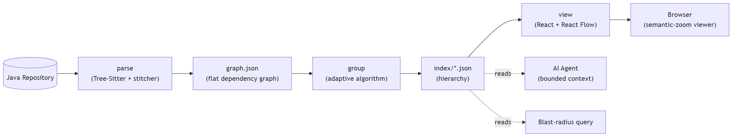
Fig. 2. The stateless file-handoff pipeline. Parsing turns a Java repository into a flat dependency graph; grouping turns that into the hierarchical index; consumers read the index directly.
Parse. The parsing layer uses Tree-Sitter to produce a per-file abstract syntax tree for each Java source file, then stitches those trees into a single cross-file dependency graph. Tree-Sitter alone yields only per-file syntax trees. The cross-file graph, which is the artifact that matters, comes from RepoHIVE's own resolution logic, which follows the Java type-resolution precedence of single-type imports, then the enclosing package, then wildcard imports. Node identity is scoped to the compilation source root, so a multi-module repository that legally repeats a fully qualified name across modules yields distinct identities and ingests correctly. The syntax trees are transient; the persisted artifact is the flat graph.
Group. The grouping layer is the research core. It ingests the flat graph, weights the edges, assesses each region's structural quality, adaptively preserves or reconstructs each region, assembles the multi-level hierarchy, and serializes a five-file index set. Section V details it.
Consume. The index is read by downstream consumers that the engine knows nothing about. Section VIII describes the three the design targets. Because the contract is fixed, a new consumer attaches without any engine change.
The stages never call each other. They communicate only through JSON files whose shape is fixed. That seam is what makes the engine substitutable at both ends: a front end for another language writes the same graph shape, and any consumer reads the same index shape.
V. The Adaptive Grouping Algorithm
The grouping layer is a pipeline of pure stages, each consuming an immutable input and producing a new immutable value, which is what makes the stages independently testable and the whole transformation a function of its input (Fig. 3). Configuration is validated before any work begins, so a parameter outside its legal domain costs an error message rather than a completed run whose numbers are quietly wrong.
[FIGURE 3 PLACEHOLDER]
Insert the regenerated six-stage algorithm diagram here.
Generation prompt: docs/paper-figure-prompts.md, Figure 3.
Fig. 3. The six-stage grouping algorithm. Configuration is validated before any work begins, and the quality-bearing stages thread their scores, decisions, and the resolved configuration into the audit record that is serialized alongside the hierarchy.
A. Ingest
The ingestor validates the input atomically and loads it into an in-memory directed weighted graph. Validation is all-or-nothing and ordered: absent input, then an empty node set, then the field types the contract states, then duplicate node identifiers, then edges referencing a missing node. Field validation covers the shape of each element, the node kinds a producer may emit, the domain of each signal, and the requirement that a class or function declares the file in which it is defined. A graph carrying two edges over the same ordered source-and-target pair is rejected rather than folded, because folding would silently rewrite the input a result is supposed to be traceable to, and because summing the signals between two entities into one edge is the producer's obligation. On any violation the ingestor returns a typed error naming the offending element and performs no partial load. On success the model contains exactly the input node and edge sets, with no additions and no removals. Rejection is preferred to repair throughout: coercing a malformed value would rewrite the evidence the result rests on, and cannot resolve an ambiguous value without inventing data.
B. Weight
Each edge receives a single non-negative dependency strength combining its three signals. The default is the linear combination a times import frequency plus b times call frequency plus c times shared-type count, with non-negative coefficients, and an edge whose signals are all zero receives strength zero. The weighting is deterministic and leans monotonic, in that more signal never decreases strength under the default function, without being required to be strictly monotonic. That leaves room to refine the function later without breaking the contract.
C. Assess
The assessor identifies candidate regions and assigns every file to exactly one primary region by a deterministic precedence rule: the most specific declared package or module boundary containing the file, or, when none is declared, the most specific directory subtree. In the Java implementation each declared package is a region, so region ownership over files is total and non-overlapping. Table I summarizes the three metrics and their normalization.
TABLE I
Structural quality metrics and their normalization
Metric | Raw definition | Mapping into [0, 1]
Cohesion | Internal edge strength divided by the region's node count. Higher means members are more strongly related. | Squashed by cohesion / (cohesion + k) for a documented constant k, default 1.0, fixing the neutral midpoint.
Coupling | Boundary-crossing strength divided by total incident strength. Lower means better isolation. | Already a ratio. Contributes its complement, since lower is better.
Modularity | Newman Q for the partition the region boundaries induce. Optional, secondary. | Mapped affinely. Dropped, with weights renormalized, when Q is undefined.

The three raw metrics live on incompatible scales, so each is mapped into the unit interval before being combined. The structural quality score is the weighted sum of the normalized terms with non-negative weights, so the score is guaranteed to lie in [0, 1]. A region with fewer than two nodes, no internal edges, or no internal strength bypasses normalization and receives a documented degenerate score rather than an undefined value. That last case matters more than it appears: a region with edges but no weight carries no signal to rebuild from, and scoring it normally would place it exactly on the default boundary, where an arbitrarily small change would flip its decision.
Two properties of the normalization are deliberate. Each mapping depends only on the region's own metric and documented constants, never on the spread of other regions in the run, so a region's score does not change when unrelated regions are added or removed. And modularity is deliberately not the primary discriminator, because Newman Q is exactly what the reconstruct step's community detection optimizes, so using it to decide whether to run community detection would beg the question. All weights and constants are written to the audit record, and the weights recorded are the weights actually applied, with modularity omitted in runs where Q was not computed.
D. Construct: the adaptive decision
This is the research core. For each primary region the constructor compares the region's score to a configurable structural quality boundary and chooses exactly one action (Fig. 4). A score at or above the boundary yields preserve: the region is already well-structured, so its existing package boundaries become group boundaries. A score below the boundary yields reconstruct: the region is poorly structured, so its groups are rebuilt by running community detection over the region's nodes and strength-weighted edges.
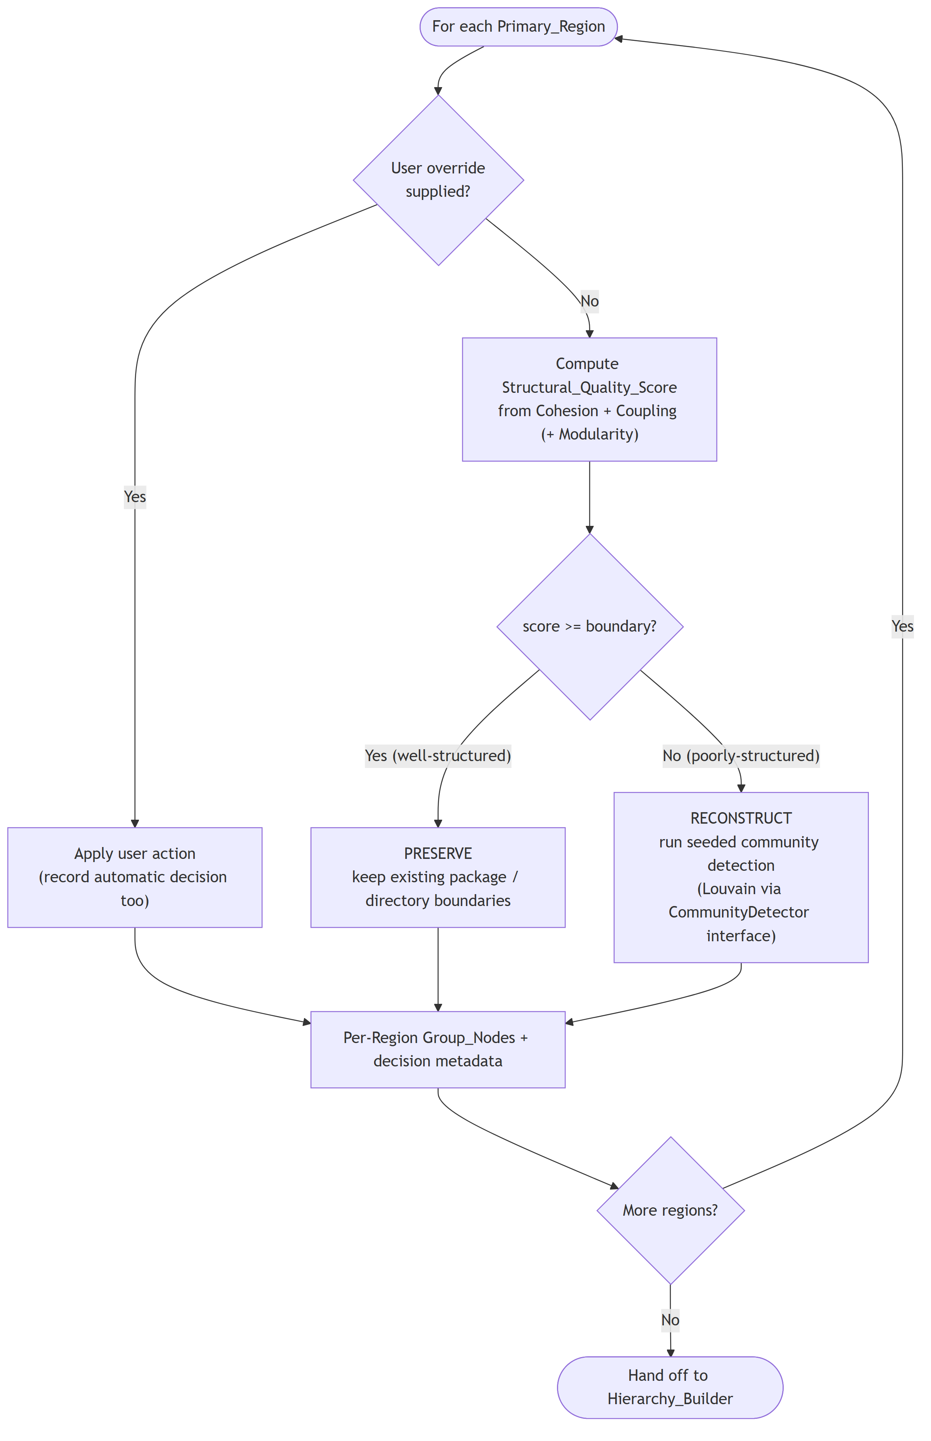
Fig. 4. The per-region preserve-versus-reconstruct decision, including the user override path. Both the applied action and the automatically computed action are recorded.
A user may override the automatic decision for any region. When that happens both the applied action and the automatically computed action are recorded, so an overridden run remains readable as an experiment rather than becoming an unexplained result. For every region the constructor records cohesion, coupling, optional modularity, the combined score, the applied action, the automatic action, whether it was overridden, and the decision confidence, defined as the absolute distance between the score and the boundary. Decision confidence is what identifies the regions that sit close enough to the boundary to flip under a small change, which is exactly the population a sensitivity analysis needs to examine.
Community detection behind an interface. The reconstruct action does not depend on Louvain directly. It depends on a detector interface. This is deliberate: the contribution is the adaptive construction policy, not any single detector. The current implementation ships a Louvain-based detector; Leiden, Infomap, or label-propagation detectors substitute without changing any other component, which also makes a detector comparison a low-cost future experiment. Because the default Louvain implementation is order-sensitive and seed-sensitive, the detector runs it with a fixed seeded generator over canonically sorted nodes and edges, then relabels the resulting communities by a content-derived key, so the reconstruct action is reproducible. A region whose internal edges carry no strength collapses to a single community rather than exploding into one group per file, which keeps a signal-free region from manufacturing spurious structure.
E. Assemble
The hierarchy builder assembles the per-region group results into the multi-level tree of Fig. 5: a single repository root, then level 1 and level 2 groups, then files, then the functions and classes defined in each file. It enforces a configurable maximum group size. Any group exceeding the limit is partitioned into the provably minimum number of balanced subgroups, that is, the ceiling of n divided by the maximum, whose sizes differ by at most one, filled from a canonically sorted child list. This bounds the branching factor at every node, so no single view overwhelms the reader, and derives hierarchy depth from the file count and the size bound rather than fixing it in advance.
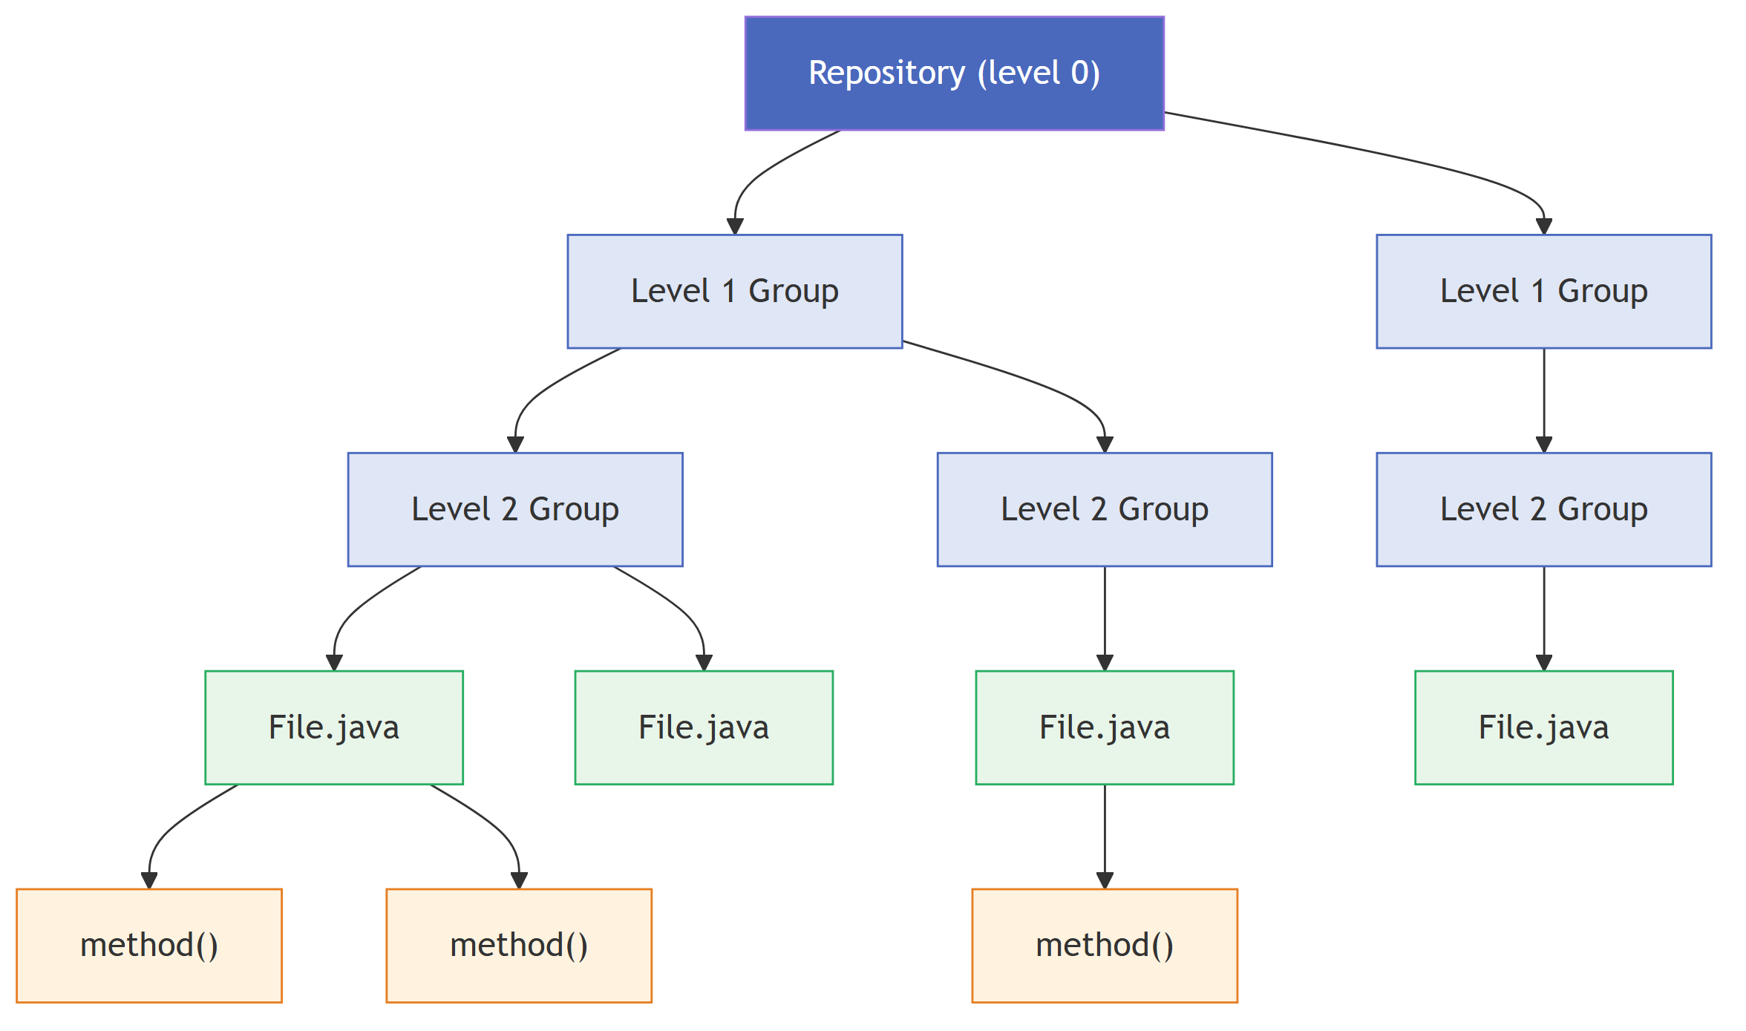
Fig. 5. The multi-level hierarchy: repository, level 1 groups, level 2 groups, files, and the functions defined in each file.
The builder preserves all dependency information. Every original leaf-to-leaf edge is retained with its direction and strength. When two connected leaves fall under different groups, a cross-group edge is created between their immediate parent groups at the lowest level where their ancestors differ, and its weight is the sum of the strengths of the leaf edges it aggregates. The set of leaf-to-leaf reachability relationships in the output equals that of the input, so the grouping neither loses nor invents a dependency.
Each group node also carries the identifier of the region it was produced from, together with an ordinal distinguishing it from the other groups of that region. This matters because a group identifier is a content hash: without the recorded provenance, a consumer confronted with several sibling groups rebuilt from one region could not tell which region they came from, nor tell them apart. The pairing of region and ordinal is unique across the hierarchy, so a consumer can always name a group unambiguously without the engine committing to any display wording.
F. Serialize
Finally the hierarchy and its metadata are written as a five-file index set covering the repository, the containment tree, the nodes, the edges, and the audit record. The set is written atomically: every payload is rendered in memory and staged in full before the target is touched, so a run either replaces the whole set or leaves the previous one intact, and a reader never observes files from two different runs side by side. The index reads back with full round-trip fidelity, recovering the same node set, edge set, per-region decisions, and depth. On read, the containment tree is verified to be a single-rooted acyclic tree in which every node is reachable exactly once and sibling ordering is canonical, and the counts stated in one file are checked against the hierarchy described by the others. The audit record additionally carries per-level node and edge counts, total cross-group edges, and the average branching factor, so the scalability of the hierarchical output can be quantified against the flat graph directly from the artifact.
VI. Determinism
Determinism is a hard requirement rather than a nicety. An evaluation that compares construction strategies, or a sensitivity analysis that sweeps the decision boundary, is only meaningful if re-running the pipeline on the same input reproduces the same hierarchy exactly. RepoHIVE enforces determinism with four rules applied throughout.
Canonical ordering. Any iteration over nodes or edges that can affect output runs over a collection sorted by node identifier, and for edges by the source and target pair, never over insertion or input order. The engine uses one canonical order throughout, byte-wise over the UTF-8 encoding of the identifier. Byte order is used rather than the host language's native string comparison because it is encoding-independent: a consumer written in another language derives the same order from the same bytes without knowing anything about the producer's internal string representation.
Order independence. Because ordering is canonical rather than positional, permuting the nodes or edges of the input leaves the output hierarchy unchanged. The edge comparator is a total order over edge content, not merely over the endpoint pair, so two edges between the same endpoints are ordered by their signals rather than left in input order by a stable sort. Without that, reordering the input could change downstream accumulation, which is the subtlest way a pipeline of this shape can lose reproducibility.
No ambient nondeterminism. Identifiers are never derived from counters, timestamps, wall-clock values, memory addresses, random values, or input position, and community detection uses a fixed seed. Where an ordinal is needed, as for the group provenance of Section V-E, it is an index into an already-canonical list rather than a counter that spans the run.
Content-addressed identity. Every group node's identifier is a hash of its canonicalized membership, so identical contents always yield the identical identifier regardless of how the group was produced, and distinct memberships yield distinct identifiers. Identity is therefore a function of content alone, which is what allows two runs, or two machines, to agree without coordinating.
Together these rules make the whole transformation a deterministic function of the input graph and the configuration. The properties are verified by property-based testing rather than by example: generators produce large families of valid dependency graphs with controllable size, package structure, diamond and cyclic shapes, and degenerate single-node or edgeless regions, and each invariant is asserted across many generated inputs. The invariants checked include set-preserving ingestion, score range, partition minimality, canonical sibling ordering, round-trip fidelity, order independence under permutation, and terminating traversal on cyclic input. A separate end-to-end check runs the full pipeline repeatedly over one repository and compares the SHA-256 digest of the serialized index across runs.
VII. Reproducibility and Auditability
Determinism guarantees that the same inputs give the same output. Reproducibility is the stronger property that a reader holding only the output can recover what those inputs were. RepoHIVE achieves it by writing the full resolved configuration into the audit record alongside the results it produced.
The distinction between the supplied and the resolved configuration matters. A caller typically sets one or two parameters and inherits the rest from defaults. Recording only what the caller supplied would leave the reader to guess the defaults of the version that ran, which is exactly the information that goes stale. The record therefore holds every parameter with its effective value, whether it was set explicitly or inherited. Table II lists the recorded fields.
TABLE II
Configuration recorded in the audit record
Recorded field | Role in reproducing the run
Structural quality boundary | The preserve-versus-reconstruct line. Reproduces every decision from the recorded scores.
Metric weights | The weights actually applied to cohesion, coupling, and modularity, with modularity omitted where Q was not computed.
Cohesion squash constant | Fixes the neutral midpoint of the cohesion mapping, so scores are comparable across runs.
Degenerate score | The value assigned to regions with too little structure to score.
Weight coefficients | The per-signal coefficients of the dependency strength function.
Community detection seed | Makes the reconstruct action reproducible.
Maximum group size | Bounds branching and therefore determines hierarchy depth and shape.
Minimum partition threshold | Reserved size bound retained for forward compatibility.
Region override map | Any region whose decision was set by hand, recorded beside the automatic decision it replaced.

Two consequences follow, and they are the reason this section exists rather than being a paragraph in Section VI. First, a boundary sweep becomes post-processing. Because each region's score and the boundary that was applied are both recorded, the decision at any other boundary value is recoverable by comparison against the recorded score, with no need to re-run assessment or community detection. Sweeping the boundary across its range and recomputing the navigation metrics is therefore a pure function of the audit record. This is what turns the boundary from a hidden constant into an empirically calibrated parameter, and it is what makes the sensitivity analysis of Section XI cheap enough to run across a whole corpus.
Second, the run is reproducible from a documented invocation. Every parameter the evaluation varies is settable from the command line, so a sweep is a shell loop over documented arguments rather than a sequence of edits to source. The values supplied are validated against their legal domains before any work begins, so an invocation either runs with the parameters as stated or fails with a message naming the offending parameter. A reported configuration and the configuration that ran cannot diverge.
Integrity of the artifact supports the same goal. Input is validated atomically and rejected with a structured error rather than partially loaded, output is written atomically, and the containment tree and inter-file counts are re-verified on read. A result therefore either exists in full and self-consistently, or does not exist. There is no state in which a reader can be misled by an artifact that looks complete but describes two different runs.
VIII. The Stable Contract and Its Consumers
The stable JSON contract is what lets one engine serve several very different consumers without special-casing any of them. Fig. 6 shows the core data model. The parser writes the graph shape; the grouping layer writes the index shape; every consumer reads it.
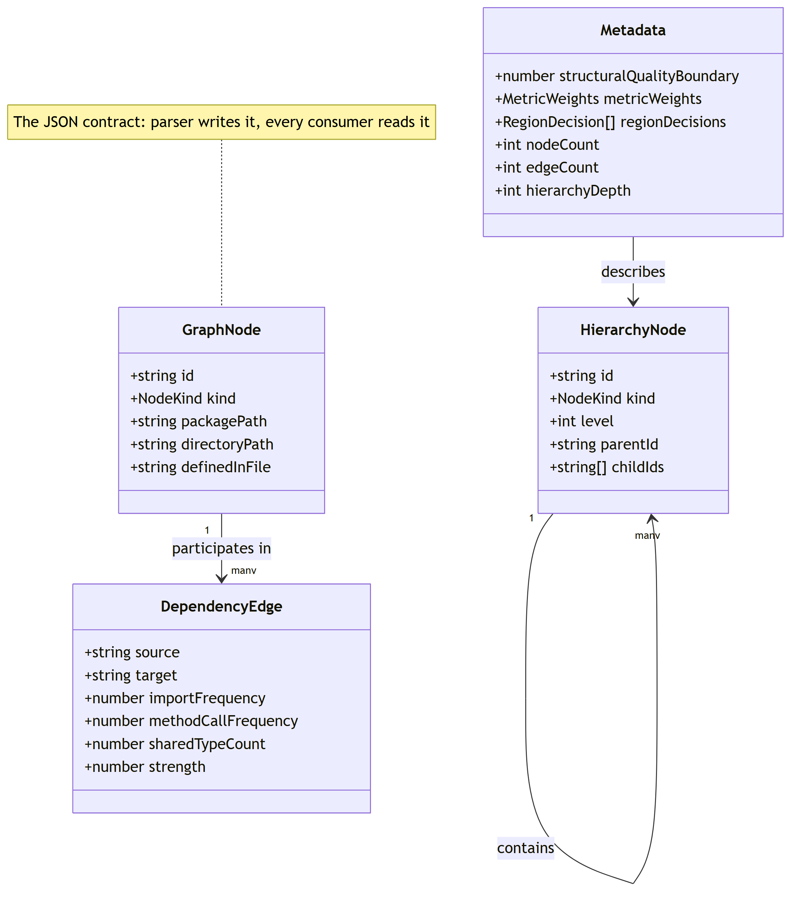
Fig. 6. The contract data model. The node and edge types are the parser's output, the hierarchy node is the grouping layer's output, and the audit record carries the scores, decisions, and resolved configuration.
Consumer 1, a semantic-zoom viewer. A viewer reads the hierarchy and renders roughly one level at a time, so drawing cost is bounded by the branching factor rather than by repository size. This is the direct expression of Claim A: bounded cognition is respected because the whole graph is never drawn. Because each group node carries its region provenance and each decision names the groups it produced, a viewer can show which regions were preserved and which were reconstructed, and with what confidence, without recomputing anything.
Consumer 2, a bounded-context agent. An agent reads the same index and descends the hierarchy to load only the relevant branch as context, rather than the whole repository. This is an engineering response to the lost-in-the-middle finding [8]: because a model uses the middle of a long context poorly, the productive move is not a larger prompt but a smaller, better-targeted one, and the layered-context result of Ehsani et al. [1] suggests structured delivery outperforms supplying everything at once. The hierarchy provides the structure needed to select that slice.
Consumer 3, a static impact query. The same index answers impact questions without any additional index, as described next.
Because all three consume the identical contract, the engine is decoupled from every one of them, and a fourth consumer requires no engine change. We note the seam as an architectural property rather than as a set of delivered products.
IX. Blast-Radius Analysis
Given a modified entity, a developer often wants to know what else could be affected. RepoHIVE answers this with a query over the preserved dependency edges: starting from the target node, it traverses edges in the dependent-to-dependency direction, following who depends on whom, and returns the set of entities that reach the target together with the groups containing any impacted leaf. Fig. 7 illustrates the idea.
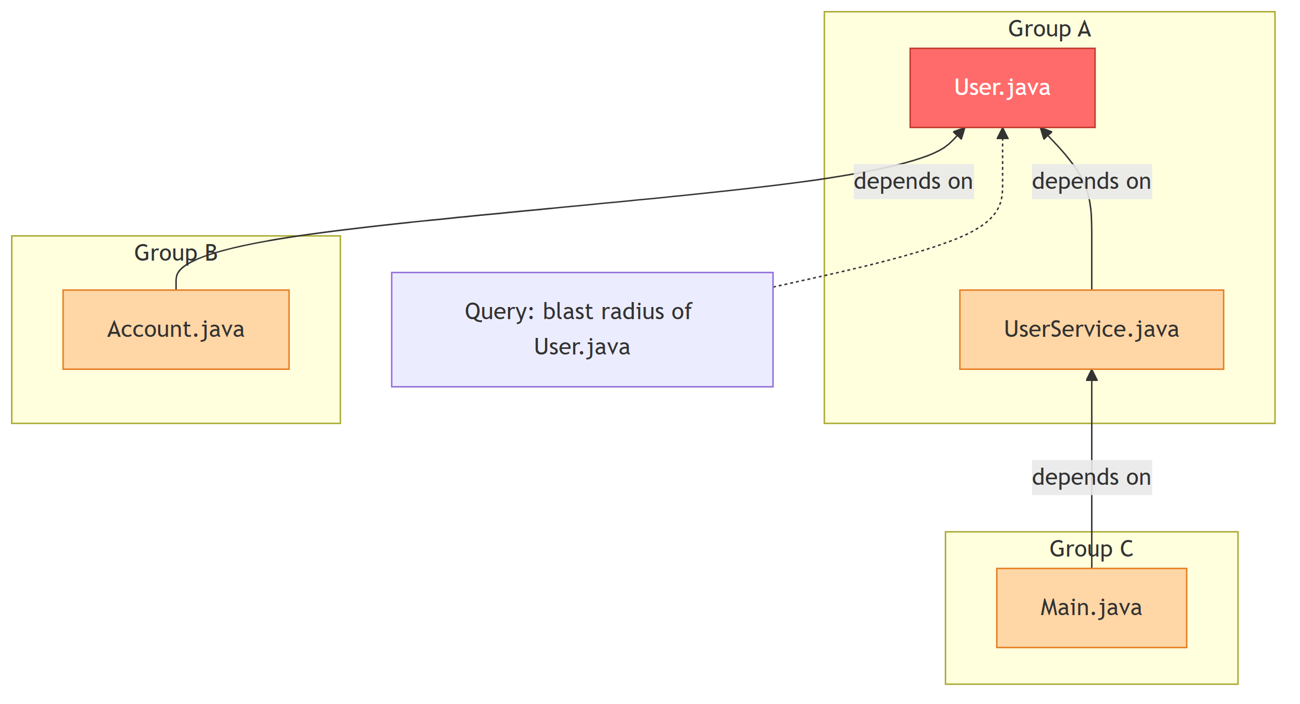
Fig. 7. Blast radius as reverse reachability. The target and all its transitive dependents are returned, along with the groups that contain them.
The traversal maintains a visited set, so each node is reported at most once and a cyclic dependency graph terminates. The ancestor walk that collects containing groups maintains its own visited set for the same reason, since a caller may supply a hierarchy the builder did not produce. The query is deterministic, returning an identical set on repeated queries over an unchanged hierarchy. A node with no incoming dependencies yields a blast radius containing only itself, and an unknown or empty identifier returns a typed error leaving the hierarchy unchanged.
We are explicit about the limits. The blast radius is static reachability over the dependencies visible in the parsed structure. It does not capture dynamic dependencies such as reflection, dependency injection, and string-based lookups, all common in Java and its frameworks, and it will therefore under-count impact in codebases that rely on them. We report blast radius as a navigational and impact-scoping aid, not as a sound over-approximation of runtime effects.
X. Implementation
RepoHIVE is implemented in TypeScript on Node.js. The core libraries are a graph library for the in-memory directed weighted graph and its traversal utilities, a Louvain implementation used behind the detector interface and seeded deterministically, a metrics library for the optional Newman modularity signal, and a property-based testing library. Tree-Sitter's Java grammar is the only language binding required.
The system is deliberately scoped to Java first. Java is the most studied language in the software clustering literature [10], its explicit imports make cross-file dependency resolution tractable relative to dynamically typed languages, and the Tree-Sitter Java grammar is mature. The data model and interfaces are kept general, so additional ecosystems and additional region strategies, such as module and directory subtrees, can be added without interface changes.
Storage is plain JSON files on disk. At the thousands-of-files scale this work targets, no database is required, and a graph-native store remains a documented option behind the storage seam rather than a current dependency.
The dependency signal is derived from imports, from same-package name resolution, and from type-use references, that is, field and parameter and return types, supertype clauses, and object creation. Populating the shared-type signal from type-use references is what makes intra-package structure visible, and therefore what allows a well-structured package to score highly enough to be preserved. Method-call frequency remains a deliberate future refinement, since attributing a call to the correct receiver requires type inference that the current resolution layer does not perform. The contract shape already carries the signal, so sharpening it later changes numbers rather than structure.
XI. Evaluation Design
The evaluation is framed strictly around code navigation, that is, helping a developer or agent move through and understand an unfamiliar codebase, and explicitly not around recovering a ground-truth architecture. We make no claim that reconstructed groups correspond to intended modules. The only question is whether the resulting hierarchy is easier to navigate.
All three configurations run the identical pipeline and differ only in the construction decision, so any difference is attributable to the construction policy alone. Always-preserve forces a preserve action for every region, equivalently a boundary below every score. Always-reconstruct forces a reconstruct action for every region, equivalently a boundary above every score. Adaptive is the per-region decision driven by the structural quality score and the calibrated boundary. Because the baselines are reachable purely through configuration, the comparison is clean, deterministic, and requires no separate code path, and each baseline is recorded in its own audit record exactly like any other run.
The navigation-oriented metrics, each computed deterministically from the produced hierarchy, are the following.
- Expansion steps to locate a file, the number of group levels that must be expanded to reach a file from the root, reported as a distribution over all files.
- Average and maximum branching factor, children per group, and how evenly branching is distributed, since a hierarchy that respects the size bound but is lopsided is harder to scan.
- Cross-group edge count and weight per level. Fewer and lighter cross-group edges mean a navigator following a dependency more often stays within a group, which indicates groups that localize related code.
- Balance of sibling group sizes, the spread of group sizes at each level.
- Stability across input permutations. The navigation metrics must be identical when the input node and edge order is permuted. A navigation aid whose shape changes under reordering is not trustworthy.
Corpus. The intended corpus is a set of open-source Java repositories at the thousands-of-files scale, consistent with the problem statement and with the Java benchmark systems standard in the clustering literature [10]. The corpus must include at least one repository organized by feature or domain and at least one organized by architectural layer, because the two exercise opposite branches of the decision: feature-packaged code tends to produce cohesive regions that score above the boundary, while layer-packaged code tends to produce regions whose members collaborate outward rather than inward. Table III records the corpus.
TABLE III
Evaluation corpus
Repository | Files | Nodes | Edges | Packaging style
[[DATA: repo]] | [[DATA]] | [[DATA]] | [[DATA]] | [[DATA: feature/layer]]

Sensitivity analysis. Because every run records each region's score and the applied boundary, a sweep over the boundary, and secondarily over the per-metric weights and the cohesion constant, is a pure post-processing exercise, as established in Section VII. Plotting the navigation metrics against the boundary shows how sensitive navigability is to where the preserve-versus-reconstruct line is drawn, and the decision-confidence distribution identifies the regions that flip near it. This is what turns the boundary into an empirically calibrated parameter and forms the core of the research defense, again strictly in service of navigation rather than architecture reconstruction.
XII. Results
This section reports the measured behavior of the completed pipeline. Figures are given as placeholders where the corpus run supplies them, and every quantity below is either measured or explicitly labeled an estimate. We do not report a comparative result for Claim B; the tables are shaped to receive it once the corpus run completes.
A. Both branches of the decision fire
The precondition for the adaptive policy to be meaningful is that both actions occur on real code. If every region on every real repository reconstructed, the policy would reduce to the always-reconstruct baseline and the contribution would be vacuous. Table IV reports the split. A feature-packaged repository is expected to yield a substantial preserved fraction, and a layer-packaged repository a mostly reconstructed one, which is the correct answer for each rather than a deficiency in either.
TABLE IV
Per-region decisions by repository and packaging style
Repository | Regions | Preserved | Reconstructed | Mean conf.
[[DATA: repo]] | [[DATA]] | [[DATA]] | [[DATA]] | [[DATA]]

B. Navigation metrics across construction policies
Table V reports the navigation metrics of Section XI for the three configurations on each repository. Because the three differ only in the construction decision, differences are attributable to the policy. We state the expected shape of the result rather than asserting it: the honest expectation is graceful degradation, in which adaptive tracks the better of the two global baselines on uniformly structured repositories and separates from both only where region quality is genuinely mixed. Whether that separation is present, and whether it is large enough to matter, is what this table decides.
TABLE V
Navigation metrics by construction policy
Repository | Policy | Mean steps | Max branch | Cross-group edges
[[DATA: repo]] | Always-preserve | [[DATA]] | [[DATA]] | [[DATA]]
 | Always-reconstruct | [[DATA]] | [[DATA]] | [[DATA]]
 | Adaptive | [[DATA]] | [[DATA]] | [[DATA]]

C. Determinism, measured
Determinism is verified rather than assumed. Repeated runs of the full pipeline over an unchanged repository produce a byte-identical index, confirmed by comparing the SHA-256 digest of the serialized set across runs, and a run over a permuted copy of the input produces the same digest as the unpermuted original. Table VI records both.
TABLE VI
Determinism verification
Repository | Runs | Index digest (SHA-256, truncated) | Digest under permuted input
[[DATA: repo]] | [[DATA: n]] | [[DATA: digest]] | [[DATA: identical or not]]

D. Boundary sensitivity
Fig. 8 plots the navigation metrics against the structural quality boundary for each repository. The shape of these curves is the practical question behind the calibration: a broad plateau means the operating point is not delicate, whereas a sharp transition means the boundary must be chosen and reported with care. The decision-confidence distribution recorded per region identifies which regions move at each step.
[FIGURE 8 PLACEHOLDER]
Insert the boundary sensitivity plot here.
What to plot: docs/paper-figure-prompts.md, Figure 8.
Fig. 8. Sensitivity of navigation cost to the structural quality boundary. Each line is one repository; the dashed vertical rule marks the calibrated operating point. Because every region's score is recorded, the sweep is computed from the audit record without re-running assessment.
E. Cost
The pipeline is a one-time batch job rather than an interactive wait. Measured wall-clock time for each stage is reported as [[DATA: parse and group wall-clock per repository]], and the size of the serialized index as [[DATA: index size per repository]]. Where a figure is not yet measured we label it an estimate: for a repository of a few thousand Java files we estimate parsing on the order of tens of seconds to a couple of minutes, dominated by reading thousands of files rather than by parsing itself, and grouping on the order of seconds to about a minute, since community detection runs only on the reconstructed regions and handles tens of thousands of edges comfortably. We deliberately avoid headline multipliers and order-of-magnitude claims.
XIII. Limitations and Threats to Validity
We state the limitations openly, because they are what a careful reader will probe.
- Adaptive superiority is a hypothesis. Claim B, that adaptive construction beats both global baselines on mixed-quality repositories, is the subject of the evaluation, not an established finding. The honest expected outcome is graceful degradation: adaptive should never be worse than the better global baseline, and strictly better only where region quality is genuinely mixed. What the paper asserts is the mechanism, that both branches fire on real repositories.
- Blast radius is static. As noted in Section IX, it misses reflection, dependency injection, and string-based lookups, and will under-count impact in code that relies on them.
- Cohesion is scale-relative. Cohesion is normalized by node count, so two regions with the same internal strength per node but very different sizes are treated as equivalent. A density-based normalization, dividing by the number of possible intra-region edges, is a documented refinement.
- One signal remains coarse. Method-call frequency is not yet attributed to a receiver type, so dependency strength is driven by imports, same-package resolution, and type-use references. The contract shape already carries the signal, so refining it changes the numbers rather than the structure, but strength values in this paper should be read with that in mind.
- Single language and single scale tier. Results are demonstrated at the thousands-of-files scale on Java. We do not claim scaling to hundreds of thousands of files or to arbitrary languages, both of which are explicitly future work.
- Region identification is package-based. Each declared package is a region in the current implementation. Repositories that carry meaningful structure in directories rather than packages, or in build modules, are handled by the documented fallback but are not the case the evaluation exercises most heavily.
- Token-saving claims are bounded. A saving from a graph over raw files is shared with existing tools and is table stakes. Our specific claim is only the incremental saving from delivering a hierarchical branch rather than a flat graph, which we measure rather than assert.
- No claim of overall superiority. Broad code-intelligence systems address a far wider feature set. The contribution here is narrow and specific, deterministic and adaptive hierarchical navigation, and we make no claim beyond that slice.
XIV. Conclusion and Future Work
We presented RepoHIVE, a system that turns the flat dependency graph of a large Java repository into a deterministic, navigable, multi-level hierarchy. Its distinguishing idea is adaptive per-region construction: measure each region's structural quality, preserve it when it is already well-structured, and reconstruct it through community detection when it is not, rather than imposing one global grouping method. The construction is deterministic by design, with canonical ordering, content-addressed identity, seeded detection, and invariance under input permutation. Every score, decision, and the full resolved configuration are recorded, which makes a result reproducible from its own artifact and turns the decision boundary into an auditable, tunable parameter that a sensitivity analysis can sweep as post-processing. A stable contract lets one engine serve a semantic-zoom viewer, a bounded-context agent, and a static impact query without knowing anything about them.
Future work follows the seams the architecture already exposes. The detector interface makes a Louvain-versus-Leiden comparison a low-cost experiment. Co-change dependencies drawn from version history [5] can enrich the edge signal behind the same contract. Receiver-type inference would populate the method-call signal and sharpen dependency strength. A density-based cohesion measure addresses the scale-relative caveat, and region identification beyond declared packages would widen the set of repositories the policy applies to cleanly. Beyond the engine, the stable contract allows further consumers to attach without engine rework, and a semantic layer built on embeddings could support search and cluster naming, never grouping, which remains deterministic and structural by design.
References
[1] R. Ehsani, E. Parra, S. Haiduc, and P. Chatterjee, “Hierarchical knowledge injection for improving LLM-based program repair,” arXiv:2506.24015, 2025.
[2] M. Athale and V. Vaddina, “Knowledge graph based repository-level code generation,” arXiv:2505.14394, 2025.
[3] N. Dhulshette, S. Shah, and V. Kulkarni, “Hierarchical repository-level code summarization for business applications using local LLMs,” arXiv:2501.07857, 2025.
[4] S. Druskat et al., “Better architecture, better software, better research,” Computing in Science & Engineering, vol. 27, no. 2, pp. 45–57, 2025, doi: 10.1109/MCSE.2025.3573887.
[5] A. D. Stana and I. Sora, “Refining software clustering: The impact of code co-changes on architectural reconstruction,” IEEE Access, vol. 13, pp. 132126–132145, 2025, doi: 10.1109/ACCESS.2025.3592777.
[6] D. Sounthiraraj, J. Hancock, Y. Kortam, A. Javvaji, P. Singh, and S. Shankar, “Code-Craft: Hierarchical graph-based code summarization for enhanced context retrieval,” arXiv:2504.08975, 2025.
[7] S. Ouyang et al., “RepoGraph: Enhancing AI software engineering with repository-level code graph,” in Proc. Int. Conf. on Learning Representations (ICLR), 2025, arXiv:2410.14684.
[8] N. F. Liu et al., “Lost in the middle: How language models use long contexts,” Transactions of the Association for Computational Linguistics, vol. 12, pp. 157–173, 2024, arXiv:2307.03172.
[9] F. Zhang et al., “RepoCoder: Repository-level code completion through iterative retrieval and generation,” in Proc. Conf. on Empirical Methods in Natural Language Processing (EMNLP), 2023, arXiv:2303.12570.
[10] Q. I. Sarhan, B. S. Ahmed, M. Bures, and K. Z. Zamli, “Software module clustering: An in-depth literature analysis,” IEEE Transactions on Software Engineering, vol. 48, no. 6, pp. 1905–1928, 2022, doi: 10.1109/TSE.2020.3042553.

